**Experiment No. 4 Date**



**STUDY OF HALF WAVE AND FULL WAVE RECTIFIER**

**Aim:** Simulate the following circuits and observe the output wave forms

1. Half-wave rectifier without and with filter
2. Full-wave rectifier without and with filter

**Components Required:**

AC voltage source, Diode, Series RLC Branch, Voltage Measurement, Scope, Powergui

**Theory:**

The process of converting the AC into DC is called rectification and it is obtained through rectifier circuits, which use diodes as circuit element. For a half wave rectifier during the positive half cycle, the diode is forward biased and it conducts and hence a current flows through the load resistor. During the negative half-cycle, the diode is reverse biased and it is equivalent to an open circuit. Hence the current through the load resistance is zero. Thus the diode conducts for one half cycles and results in a half wave rectified output.

A Full wave rectifier is a circuit, which converts an AC voltage into a pulsating dc voltage using both half cycles of the applied voltage. It uses two diodes of which one conducts during one half cycle while the other conducts during the other half cycle of the applied ac voltage. During the positive cycle of the input voltage, diode D1 becomes forward biased and D2 becomes reverse biased. Hence D1 conducts and D2 remains off. The load current flows through D1 and the voltage drop across RL will be equal to the input voltage. During negative half cycle of the input voltage, diode D1 becomes reverse biased and D2 becomes forward biased. Hence D1 remains off and D2 conducts. The load current flows through D2 and the voltage drop across RL will be equal to the input voltage.

To obtain a pure DC voltage at the output, filtering is done where the AC is removed and the DC is obtained. For that capacitor is used as a filter. We can connect a high value capacitor in shunt with the load. The capacitor offers a low impedance path to the ac components of current. Most of the ac current passes through the shunt capacitor. All the dc current passes through the load resistor. The capacitor tries to maintain the output voltage constant at Vm.

The practical application of any rectifier (be it half wave or full wave) is to be used as a component in building DC power supplies. In order to build an efficient & smooth DC power supply, a full wave rectifier is always preferred. However, for applications in which a constant DC voltage is not very essential, we can use power supplies with half wave rectifier.

**Procedure**

(a)Connect the required components according to the circuit.

(b)Ensure your model 4 circuits. They are:

1.Half-wave Rectifier

* + - * Without filter
      * With filter

2.Full-wave Rectifier

* Without filter
* With filter

**Graphs**

**Half-wave Rectifier without capacitor:**

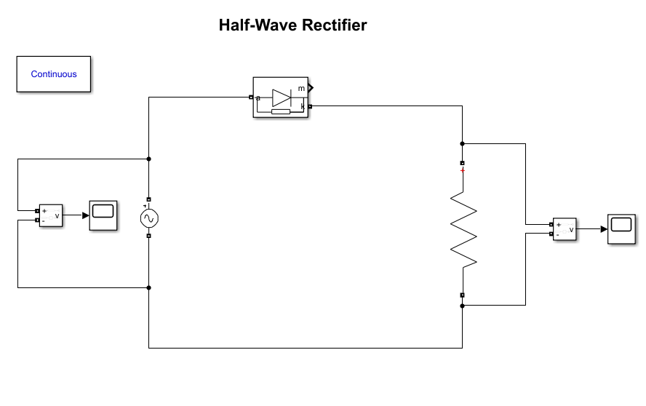

**Scope:**

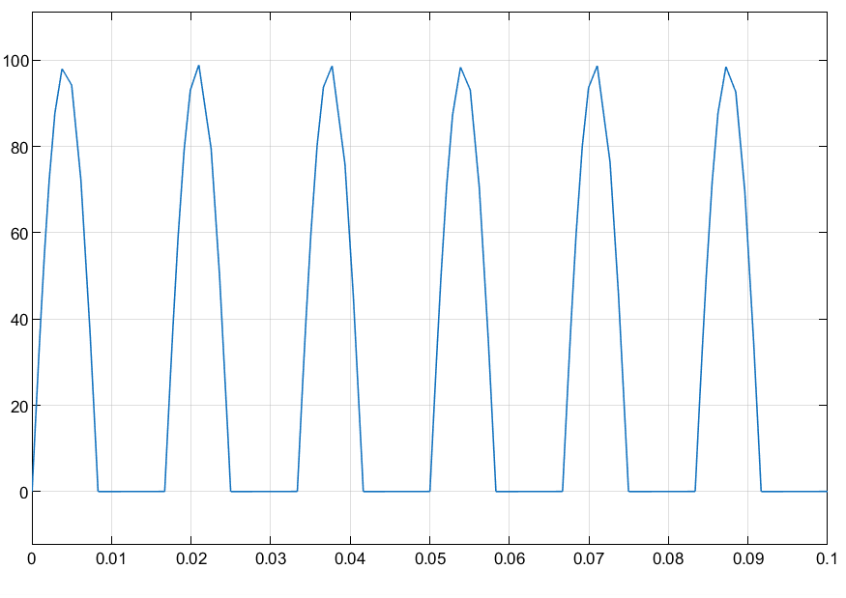

**Half-Wave Rectifier with capacitor:**

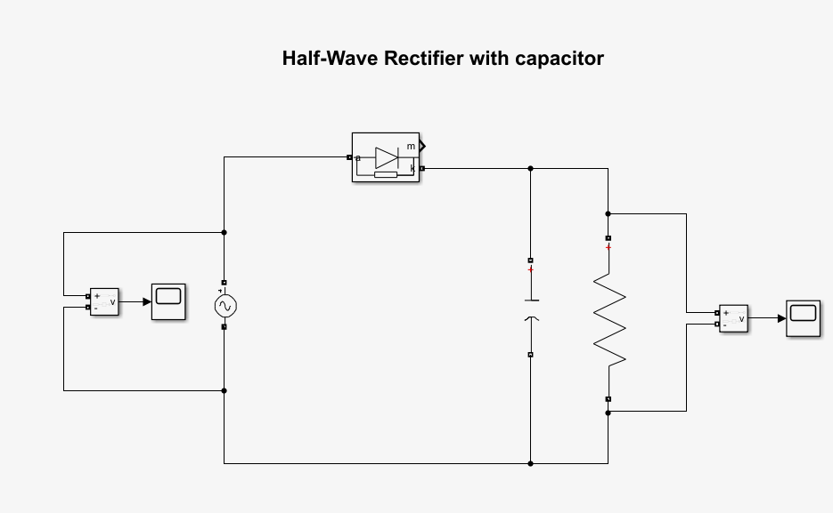

**Scope:**

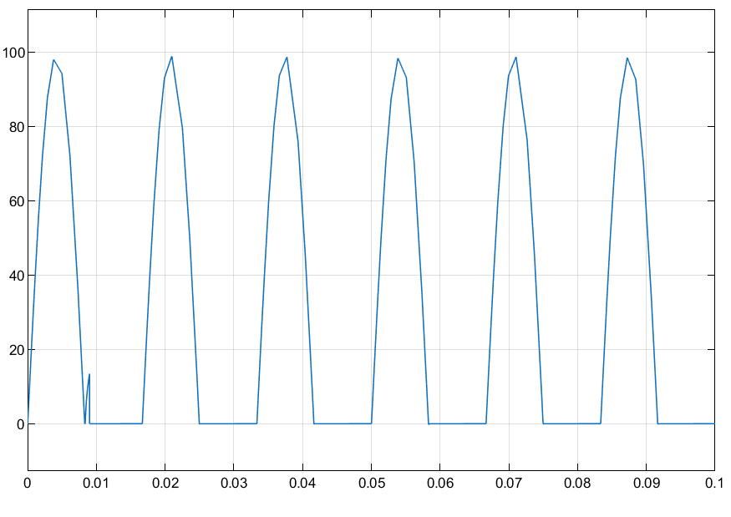

**Full-wave Rectifier without capacitor:**

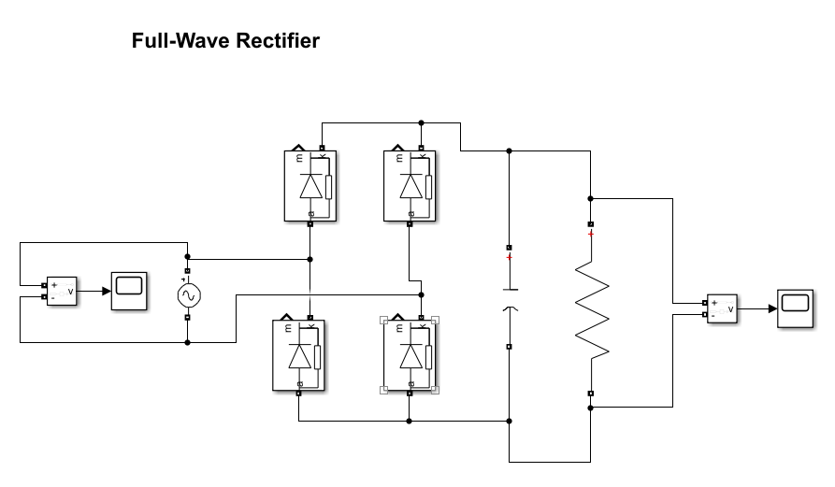

**Scope:**

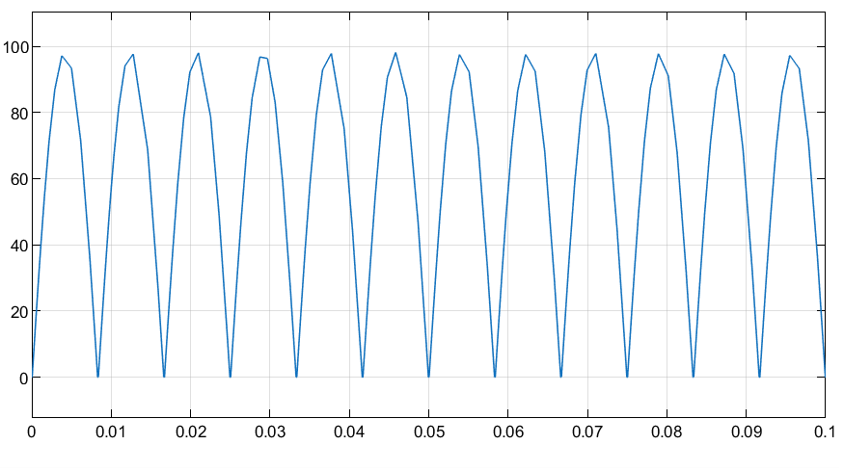

**Full-wave Rectifier with capacitor:**

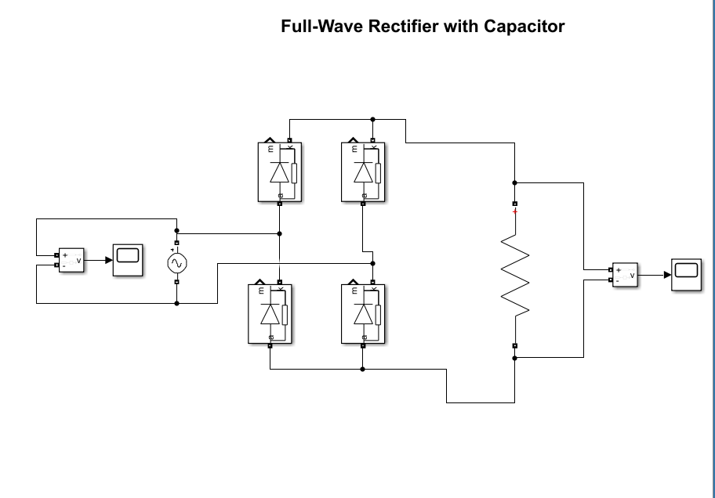

**Scope:**

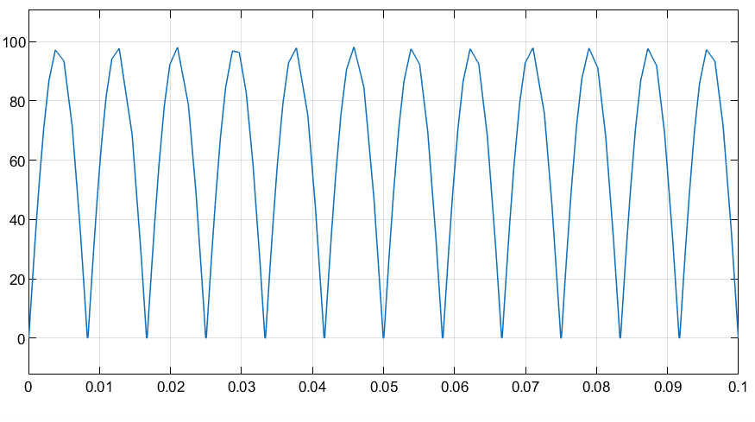

**Inference:**

The Graphs and calculations of both theoretical and practical are same

**Circuit Diagram Half wave rectifier**

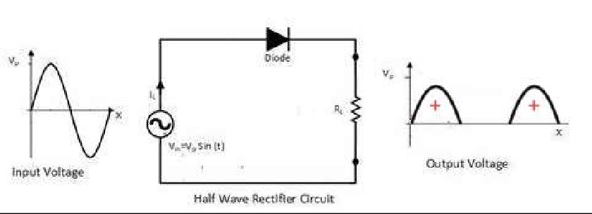

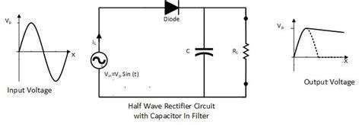

*V* = *Vm* ,*V* = *Vm* , Ripple factor *y* = *Vac*

*rms* 2 *dc* П

*Vdc*

For a sine wave which is having ac and dc component,



2 2 2

*V* = *V* + *V*

*rms ac dc*

Therefore *Vac* =

*Vrms*

2

– *Vdc*

2

Therefore Practical value *y* =

( *V*

  *rms*  –1

 *Vdc* 

2

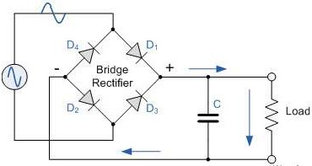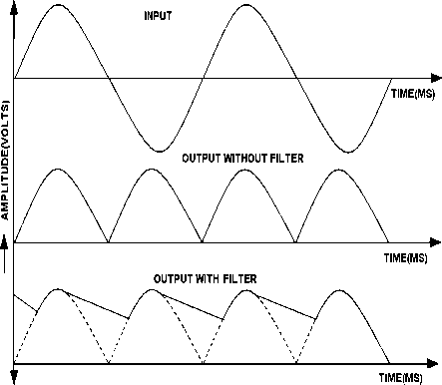**Full wave rectifier Model Graph**

Calculation: Without Filter

V rms= Vm /√ 2, Vdc = 2 Vm /π

( ***V***

  ***rms*** 

 ***Vdc*** 

2

–1

Ripple factor γ = V ac / Vdc Practical value